**Speech processing and Artificial Intelligence**

The technology has been moving forward a lot in the last decades, especially with the development of software which it can run a human order through your voice. They are devices built with Artificial Intelligence (AI) which give to the user the possibility to do other tasks with their hands while these applications run their instructions. But, could people with the communication impaired to benefiting from these software? In this post we will be able to see some terminologies which are associated to this discipline and how is regard to the research about speech.

First of all, we should unde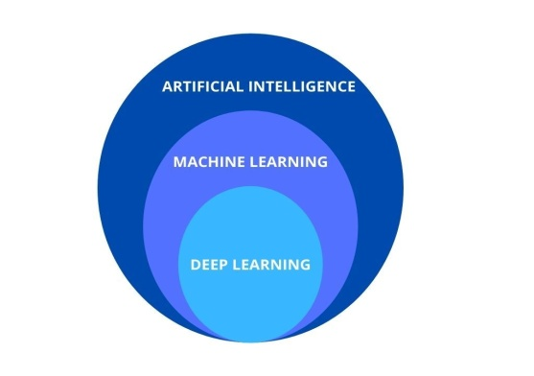rstand that the AI is a computer system trained to **perceiving the environmental, interacting with it and taking decisions.** It is made up of learning algorithms as machine learning (ML) and deep learning (DL). ML is considered as a technology with algorithms but it has a traditional learning which you can decide what features of an input you consider them relevant. By the other hand, DL is a subcategory of ML but its learning is automatic, so the algorithms automatically learning what features into the input are useful.

This technology has benefited several areas which are working better with the structure of multiples connections no lineal, producing an exchange of information more effective as is the case with some business models. Regard the research about the communication, the study on natural language processing is making through of **interdisciplinary researches** which are involving linguistic, engineering and AI. On top of that, the **cognitive system** plays a role very important on the production and comprehension language. If we compare the brain with a computer, the physical structure would be the hardware, whereas the cognitive processing would be the software. With this in mind, the language starts in this system throughout the speech production when we think what we are going to say, and finish during the speech comprehension when we understand what we just hear, suffering different brain activations (hardware) throughout the cognitive processing (software).

Even though of the studies have showed how the acoustic signal is received by the listener, changed to neural impulses, and organized in linguistic and no linguistic categories, **it is still unknown how it really is building this phenomenon.** This could be due to the cognitive science or neurolinguistic is one of the most important areas to the study of the language processing and it is one of the least attention has received by the researchers. The science has showed a greater interest about the speech signal research and in the last decades, several software have been built which with the research about the speech processing. The speech or speaker recognition devices were built with DL o ML but they are still showing challenges with the environmental noises which are interfering on the speech recognition, and the **distortion of speech code** such as a dysarthria.

The classic investigation about the language processing on the brain cortex is based in researches on healthy subjects, who have solve tasks about different language areas or recognize sounds whereas they are connected to some technology as fRMI. With this technology we can see what areas are receiving more activation with regard to the kind of linguistic task. But these investigations have better results when the activities are being performed with single words. By contrast, when it is necessary to researching the language in sentences or discourse, the number of activations on brain areas is greater and it is very difficult to registering the continuous speech signal. However, given the difficult to segment speech, this problem is also present in software built with algorithms of DL to transcribing the speech. In fact, these kinds of devices require that the user speak slowly and a quiet environmental to recognize as many words as possible.

In summarize, even though the researches on the speech and language processing, it seems there are several limitations into a buckle with the AI and the neuroscience.  We should be aware that it is necessary deepen on the knowledge about the brain so that the AI will be able to developing technology which it will benefit to patients with brain damage.  Besides, the IA should deepen in their applications to developing algorithms which they will be able to improving the research of brain a deeper and efficient level. From Auditory Cortex we propose the development of the **transdisciplinary researches or a multidisciplinary academic training** as a possible solution to deepening in the knowledge of the brain function and the intelligence technology.